**Basic Instructions No.1 JVD**

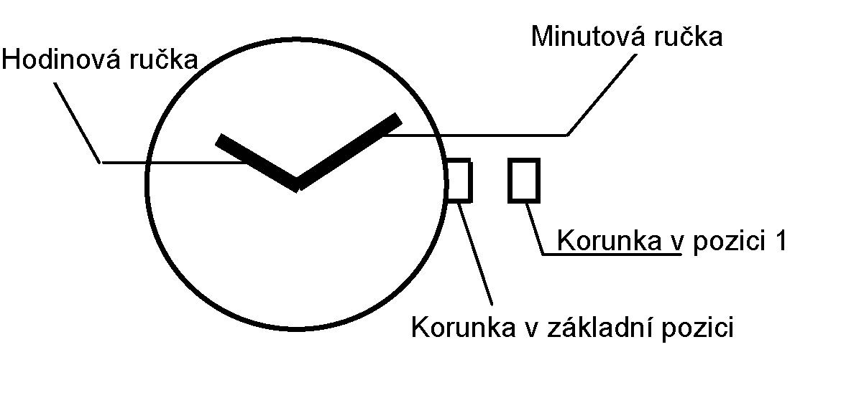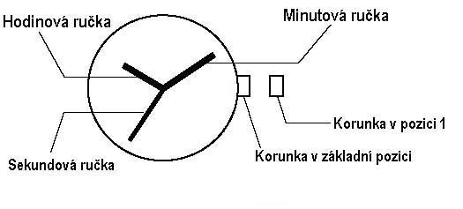

**Second hand**

**Hour hand**

**Minute hand**

**Crown in initial position**

**Crown in position 1**

**Crown in initial position**

**Crown in position 1**

**Minute hand**

**Hour hand**

**Time Setting**

1. Pull crown out to position 1. The hands stop moving.

2. Turn crown to advance minute and hour hand.

3. Return crown to initial position. The second hand starts moving.



