**Instruction manual No.14 JVD.**

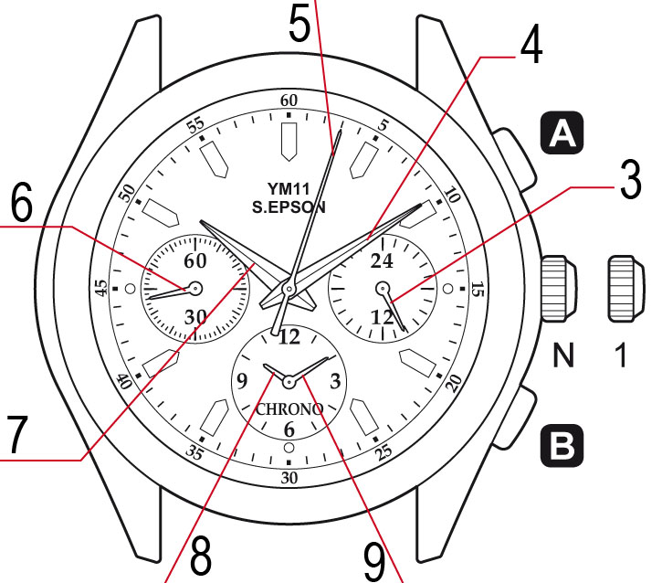**Elements of the dial:**

1. 24-hour hand
2. Minute hand
3. Second hand (stopwatch)
4. Second hand
5. Hour hand
6. Hour hand (stopwatch)
7. Minute hand (stopwatch)

**Functions of the crown:**

1. Crown in initial position – regular use
2. Crown in position 1 – setting of time and initial position for the stopwatch

**Time setting:**

1. Pull crown out to position 1 when the second hand is at 12:00. Second hand stops moving – this can be used for precise time setting.
2. Turn crown to advance hour and minute hand. Pay attention to the setting of the 24-hour hand which turns along with the hour and minute hands.
3. Push crown back to initial position (N).

*RECOMMENDATION: Set the time 4-5 minutes ahead first. Set the correct time afterwards.*

**Stopwatch**

3 stopwatch hands: hour, minute and second. The stopwatch measures up to 11:59.59. When the maximal value is reached, the stopwatch stops measuring.

**Regular measuring**:

1. Press button **A** to start measuring.

1. Press button **A** again to stop measuring.
2. Press button **B** to reset the stopwatch.

**Measuring with a pause, without time measuring in the background**:

1. Press button **A** to start measuring.

2. Press button **A** again to pause measuring.

3. Press button **A** to start measuring again from the point when you made a pause.

You can make pauses and start again as many times as you wish.

1. Press button **A** again to stop measuring.
2. Press button **B** to reset the stopwatch.

**Measuring with a pause, with time measuring in the background**:

1. Press button **A** to start measuring.
2. Press button **B** to stop the hands of the stopwatch (the time runs in the background)
3. Press button **B** to continue measuring (the hands will quickly get to place)

You can stop the movement of the hands or have them get back to place at any time

1. Press button **A** again to stop measuring.
2. Press button **B** to reset the stopwatch.

**Measuring two racers at once:**

1. Press button **A** to start measuring.
2. Press button **B** to stop measuring the first racer.
3. Press button **A** for measuring the second racer.
4. Press button **A** to stop measuring the second racer.
5. Press button **B** to reset the stopwatch.

*Attention: Make sure than the crown is in initial position (0) and the hands of the stopwatch are at 12:00 before using the stopwatch.*

**Low battery indicator**: If the battery is low, the second hand (6) starts moving in 2 second intervals instead of one second intervals. This does not affect the accuracy of the watch. It just alerts you that the battery needs to be changed as soon as possible.

**Setting the hands to position 0 if they do not return automatically:**

1. Pull crown out to position 1 (1).
2. Long press button **A** and the second hand of the stopwatch will go around the dial.
3. Press button **B** to set the position of the initial point (we recommend point 0) of the second hand of the stopwatch. Hold button **B** to speed up the process.
4. Then long press button **A** and the hour and minute hands of the stopwatch will go around the dial.
5. Press button **B** to set the position of the initial point (we recommend point 0) of the minute and hour hands of the stopwatch. Hold button **B** to speed up the process.
6. Push crown back to initial position (N).

