Instruction manual No.22
Instruction manual
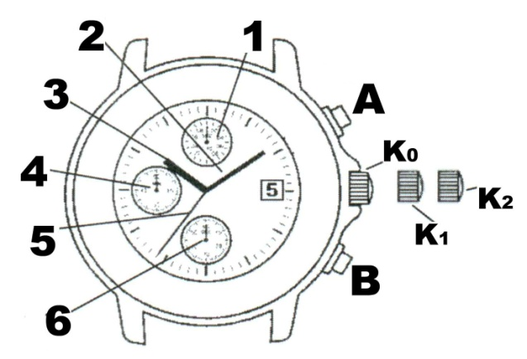
Elements of the dial:
- 1/10 second hand of the chronograph / stopwatch
- Minute hand
- Hour hand
- Minute hand of the chronograph / stopwatch
- Second hand
- Second hand of the stopwatch
Button A – start / stop of the chronograph / stopwatch
Button B – split function of the stopwatch

Crown:
K0: Crown in initial position – ordinary use
K1: Crown in position 1: date setting
K2: Crown in position 2: time setting

- The chronograph / stopwatch function works independently from the regular watch
- 1/10 second hand shows the measured values only during the first minute, then it runs in the background and it moves to the correct spot when measuring is over.

Setting of hands of the chronograph / stopwatch
Before you start setting time, make sure that 1/10 second hand of the chronograph is in position 0 (12:00).
- If the stopwatch is running, reset the stopwatch by pressing buttons A, B in this order.
- If the stopwatch is not running, reset it by pressing button B.
- If split time is shown, reset the stopwatch by pressing buttons B, A, B in this order.
If one of the hands does not return to point 0 after resetting, you need to set the hands to point 0 manually:
- Pull crown out to position 2.
- Press button A or B to reset all hands of the stopwatch. If the hands do not return to point 0 (12:00), set them to point 0 manually by pressing button A (1/10 second hand) or B (minute and second hand). You can speed up the process by holding the button.
- Push crown back after the hands have returned to point 0.

Time setting:
- Pull crown out to position 1 to set the date and set it to a day before the actual date.
ATTENTION: Never set the date between 09:00 PM and 01:11 AM! The date would change during the day instead of at night.
- Pull crown out to position 2 to set time. The stop hand stops moving (this can be used for exact time setting).
- Turn crown to set time (do not press the buttons – that would change the settings of the stopwatch).
- Push crown back to initial position. The stop hand starts moving again (this can be used for synchronization, e.g. with time signals in the radio).

ATTENTION: Screw in the cover after handling the crown to preserve water-tightness.

Using stopwatch (the stopwatch works independently from the regular watch)
- The stopwatch measures up to 59 minutes and 59 seconds.
Examples of measuring (you need to follow this exact order of pushing the buttons):
Regular measuring (e.g. 100 m run): Press button A to start measuring. Press button A again to stop measuring. Press button B to reset stopwatch (stopwatch is ready for next measuring).
Collected measuring (e.g. basketball game with a break)
Press button A to start measuring. Press button A again to stop measuring (make a break). Press button A again to start measuring again (the break does not count to the result). Press button A to stop measuring (end of game). Press button B to reset stopwatch for next measuring. (You can make as many breaks as you wish).
Split time measuring (e.g. 5 km run)
Press button A to start measuring. Press button B to stop the movement of the hands (then you can e.g. note down the measured time. The measuring still runs in the background. Press button B again to move the hands to show you the measured time and continue measuring. You can make as many split time measurements as you wish. Press button A to stop measuring. Press button B to reset stopwatch for next measuring.

