INSTRUCTION MANUAL NO.9
Instruction manual

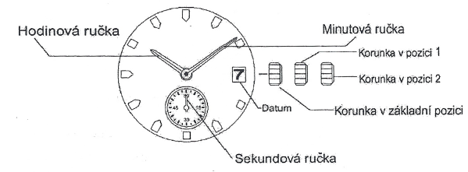
Hour hand
Second hand
Crown in initial position
Crown in position 2
Crown in position 1
Minute hand
Date

Time setting
1. Pull crown out to position 2. Second hand stops moving.
2. Turn crown to advance minute and hour hands to desired time.
3. Push crown back to initial position. Second hand starts moving.

Date setting
- Pull crown out to position 1.
- Turn crown counterclockwise to set second number of the date.
Turn crown clockwise to set first number of the date.
* Do not set date between 09:00 PM and 6:00 AM. Date would change in the afternoon instead of at night.
* You will need to set the date at the beginning of each month.
- Push crown back to initial position.


