INSTRUCTION MANUAL NO.3 JVD
Self-winding mechanical clockwork – instruction manual
Components of the dial
Minute hand
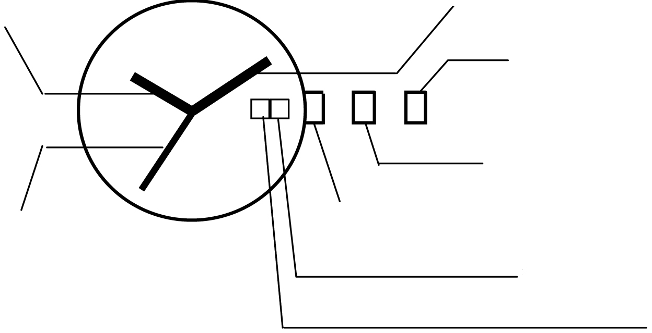
Hour hand
Crown in position 2

Crown in position 1

Crown in initial position
Second hand
Date: day of month

Day of week

Winding the clockwork: You can wind the self-winding clockwork manually too: Turn crown in initial position clockwise for manual winding. Turn 15-20 times. Shake the watch slightly – the hands will start moving.
Time setting
1. Pull crown out to position 2.
2. Turn crown to advance hour and minute hands.
3. Return crown to initial position.
Date and day of week setting
1. Pull crown out to position 1.
2. Turn crown clockwise to set day of week.
3. Turn crown counterclockwise to set date (day of month).
ATTENTION: do not set date and day of week between 09:00 PM and 04:00 AM
Time measurement deviation
All clockworks in JVD watches are adjusted, checked and tested. Yet, it is impossible to ensure absolute accuracy. There can be variations dependent on the wearer, wearing and climate conditions. Accuracy deviations appear especially during the first two months of usage. Accuracy deviations settle during the second or the third month and the watch starts to run accurately. Unless the accuracy deviation is significant, the watch should not be adjusted in the first two months following the purchase.
Following accuracy deviations are common:
Accuracy deviation for | in a day | in a week
Manual winding | − 5 to19 seconds | − 15 to 80 seconds
Automatic winding | − 6 to 20 seconds | − 20 to 90 seconds
Certified chronometer | − 2 to 5 seconds | − 8 to 20 seconds
Battery (quartz) |  | − 0,7 to 1.0 seconds

Accuracy deviations in the table are dependent on factors that the manufacturer cannot influence like temperature fluctuations, changes in air pressure, vibrations, irregular winding or cluttering.

