**Instruction manual No.15**

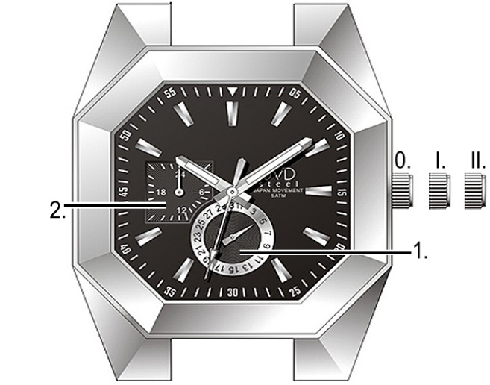Dial elements:

1. date hand

2. 24-hour hand

Crown positions:

0. initial position – regular use

I. date hand

II. 24-hour hand

Instruction manual

Time setting:

1. Pull crown out to position II. Second hand stops moving.

2. Turn crown to set time.

3. Push crown back to initial position. Second hand starts moving.

Date setting:

Never set date between 09:00 PM and 10:00 AM.

1. Pull crown out to position I.

2. Turn crown counterclockwise to set date.

3. Push crown back to initial position.

