Features:
 Radiowe sterowanie czasem DCF
 Wieczny kalendarz aż do roku 2099
 Dzień tygodnia w 7 językach: angielski, niemiecki, włoski, francuski, hiszpański, niderlandzki, duński
 Możliwość wyboru formatu czasu 12/24 godziny
 Funkcja codziennego alarmu
 Codzienny alarm z funkcją drzemki (od 5 do 60 min lub OFF)
 Wyświetlanie faz księżyca
 Ciśnienie atmosferyczne:
600–1100 hPa (17,72–32,50 inHg), możliwość wyboru jednostek hPa/mb lub inHg
Wilgotność: wewnętrzna i zewnętrzna 20 %RH–95 %RH
 Humidity: Indoor & Outdoor measurable range: 20%RH ~ 95%RH
 Temperatura::
— Wewnątrz: –9,9 °C do 50 °C (15 °F–122 °F)
— Na zewnątrz: –40 °C do 70 °C (–40 °F–158 °F)— Temperature alternatively in °C or °F.
— Możliwość wyboru °C lub °F, ostrzeżenie o mrozie
 Wyświetlanie minimalnej/maksymalnej wilgotności i temperatury
 Wireless Outdoor Sensor:
— Montaż na ścianie lub ustawienie na stole
— W zestawie jeden bezprzewodowy czujnik temperatury
— Częstotliwość transmisji radiowej 433,92 MHz
— Zasięg transmisji do 60 metrów w otwartym terenie
 Funkcja prognozy pogody
 Zasilanie:
Stacja pogodowa:
Bateria: 2 x LR6 AA
Zasilacz: DC 4.5V 150 mA

Bezprzewodowy czujnik zewnętrzny:
Bateria: 2 x LR6 AA

Weather Station Appearance
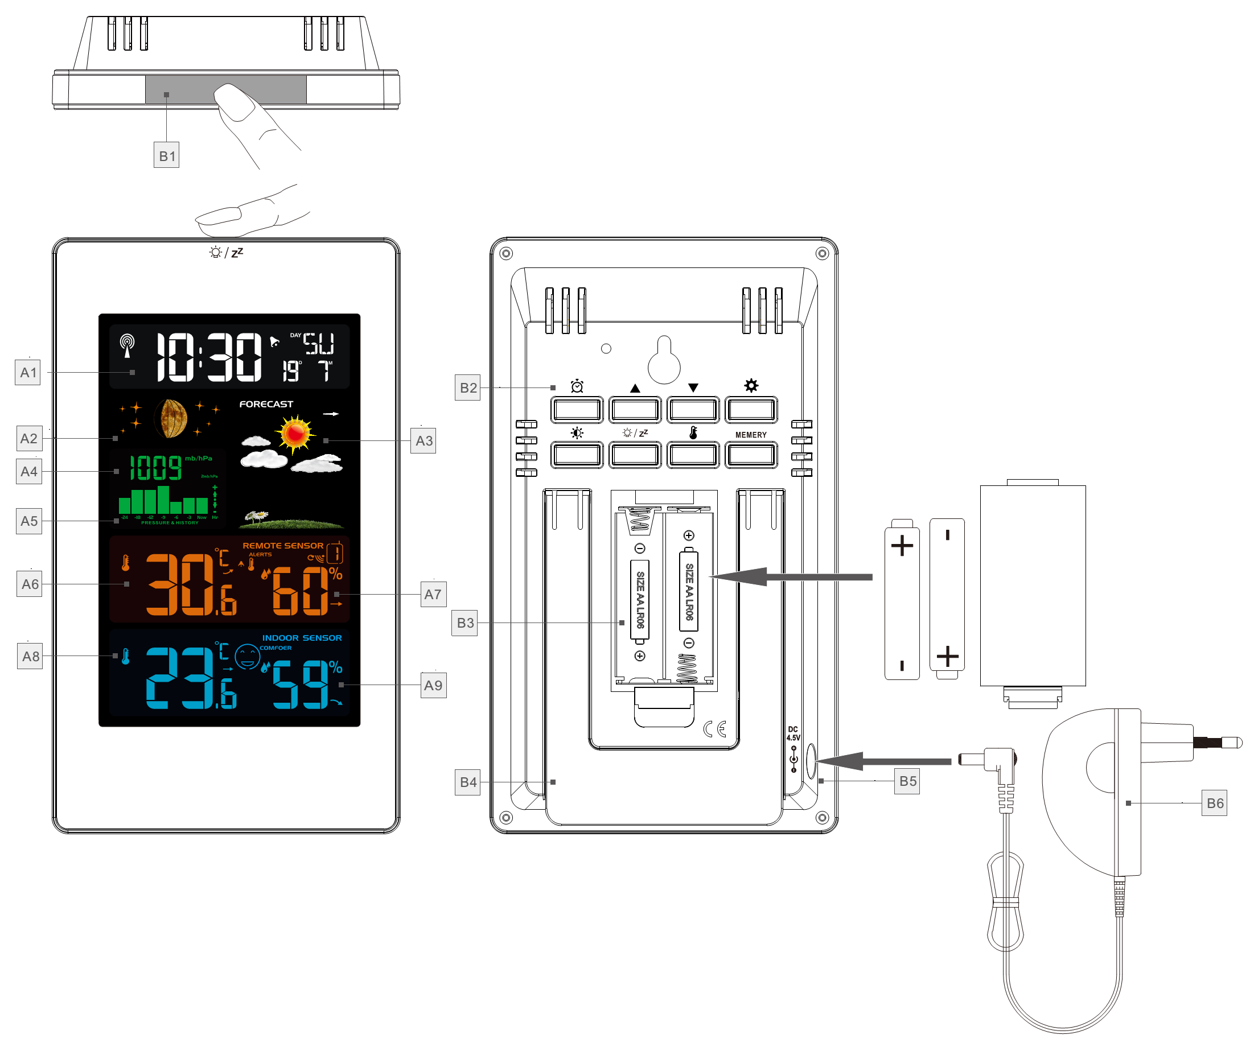
Part A-Positive LCD
A1: Time/Calendar or Alarm time/ Weed
A2: Moon Phase
A3: Weather Forecasting
A4: Barometric pressure
A5: Histogram shows the trend of 24 hours of atmospheric pressure
A6: Outdoor Temperature
A7: Outdoor Humidity
A8: Indoor Temperature
A9: Indoor Humidity
Part B – Back button and power
B1: “SNOOZE/LIGHT” touch field
B2: Keypad
B3: Battery compartment
B4: Support frame
B5: Power supply socket
B6: Mains adapter
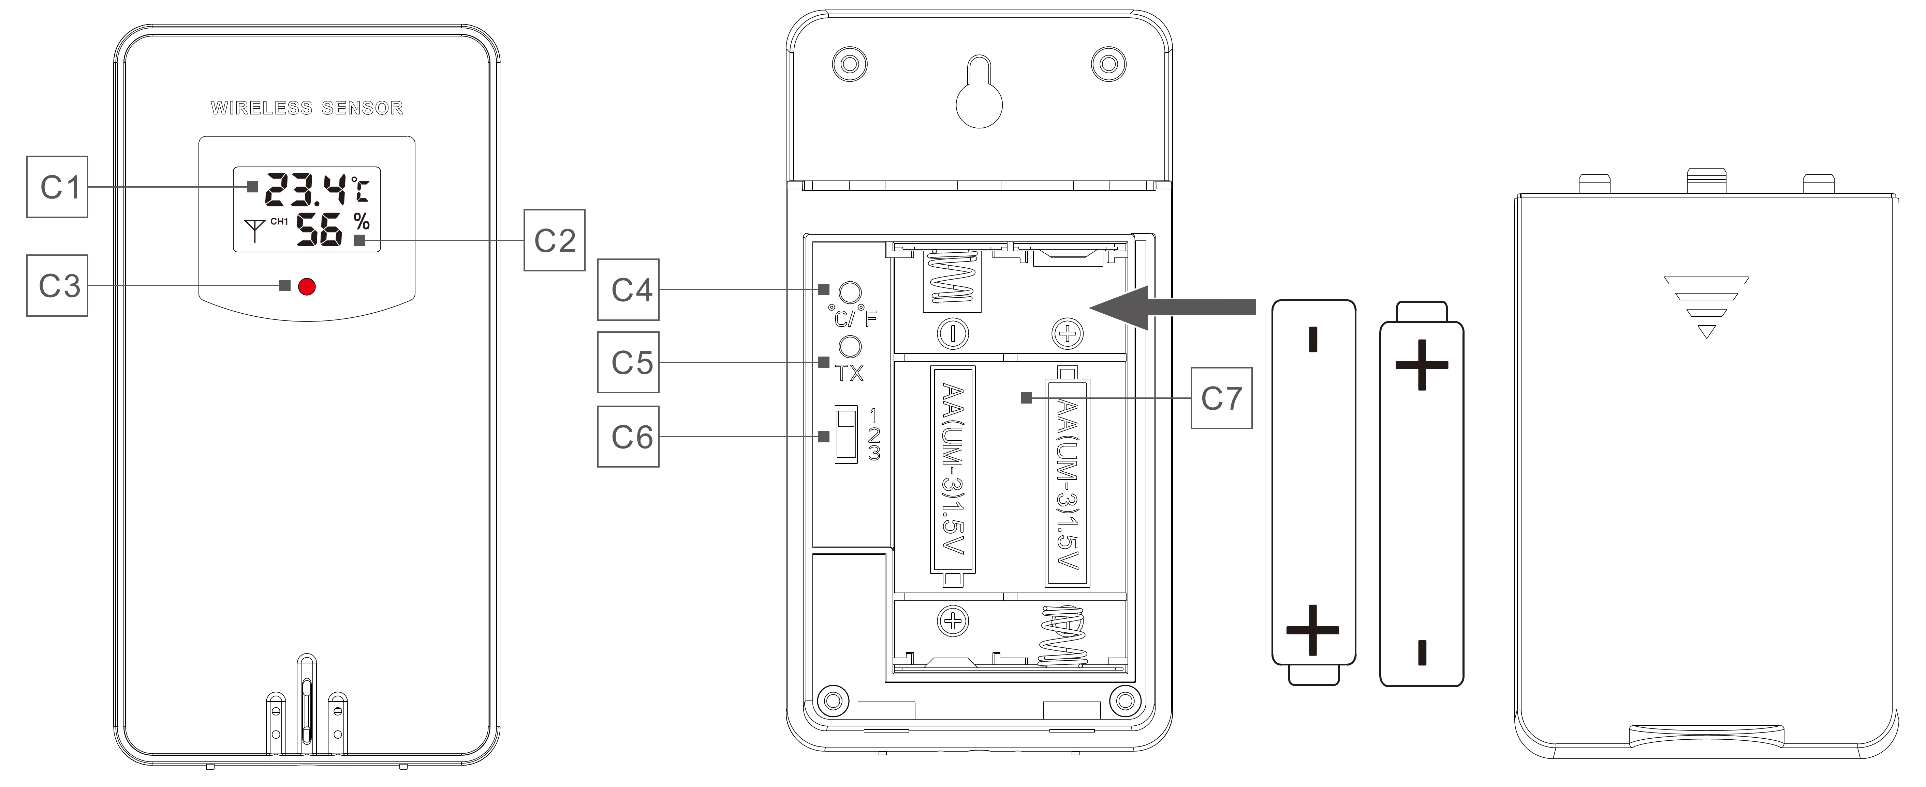

Part C –Wireless Remote Sensor:
C1: LCD display – Temperature
C2: LCD display – Humidity
C3: Transmit signal LED
C4: “°C/°F” button
C5: “TX” button
C6: “CHANNEL 1 or 2 or 3” switch
C7: Battery compartment

Initial operation:
 Open Weather Station battery compartment cover
 Insert 2 x AA batteries observing polarity [ “+” and “ –“ marks]
 When you insert the batteries, all the icon on the LCD display will briefly light up for 3 seconds, and you will hear a beep tone, and detect indoor temperature & humidity.
 The Weather Station will now start to make a connection to the outdoor remote sensor. This operation takes about 3 minutes and is displayed by a flashing reception RF antenna symbol in the “OUTDOOR” display area on the receiver.
 This now, mount the wireless outdoor sensor battery, open the wireless outdoor sensor battery box cover, insert a 2 x AA battery to observe the polarity [ “+” and “–“ marks]
 After receiver has created a connection to the outdoor remote sensor, it will then b enters the Radio control time receive mode.
Reception of the Radio signal:
 The clock automatically starts the DCF signal search after 7 minutes of any restart or changing of new fresh batteries. The radio mast icon starts to flash.
 At 1:00 /2:00 / 3:00, the clock automatically carries out the synchronization procedure with the DCF signal to correct any deviations to the exact time. If this synchronization attempt is unsuccessful (the radio mast icon disappears from the display), the system will automatically attempt another synchronization at the next full one hour. This procedure is repeated automatically up to total 5 times.
 To start manual DCF signal reception, press and hold down the “▲” button for two seconds. If no signals received within 7 minutes, then the DCF signal search stops (the radio mast icon disappears) and start again at the next full one hour.
 During RC reception，to stop searching radio signal, press the “▲” button once.

F.Y.I.:
 A flashing radio mast icon indicates that the DCF signal reception has started
 A continuously displayed radio mast icon indicates that the DCF signal was received successfully
 We recommend a minimum distance of 2.5 meters to all sources of interference, such as televisions or computer monitors
 Radio reception is weaker in rooms with concrete walls (e.g.: in cellars) and in offices. In such extreme circumstances, place the system close to the window.
 During the RC receive mode, only the “▲” button function, other button operation have no function, If you want to carry out other functions of operation, please press “▲” button to exit the RC receiving mode.

Manual time setting:
 Press once “” button, can switch the display calendar or second or alarm time
 Press and hold down the “” button for 2 seconds, the unit of temperature display starts to flash. Now use the “▲” and “▼” button to set the temperature of the unit, the unit of temperature can be set to “°C” or “°F”
 Press “” to confirm your setting, the unit of pressure display starts to flash. Now use the “▲” and “▼” button to set the pressure of the unit, the unit of t pressure can be set to “hPa” or “inHg”
 Press “” to confirm your setting, the 12/24 hour mode display starts to flash. Now use “▲” and “▼” buttons to set the correct 12/24 hour mode.
 Press “” to confirm your setting, the RCC icon display starts to flash, Now use “▲” and “▼” buttons set the RCC receive function to activate(ON) or close(OFF)
 Press “” to confirm your setting, the Time zones start to flash, Now use “▲” and “▼” buttons set a correct time zone (-12 to +12).
 Press “” to confirm your setting, the Hour display starts to flash. Now use “▲” and “▼” buttons to set the correct hour.
 Press “” to confirm your setting, the Minute displays starts to flash. Now use“▲” and “▼” buttons to set the correct minute.
 Press “” button to confirm your setting, the Month and Date icon display starts to flash. Now use “▲” and “▼” buttons to set the date display on Month/Date or Date/Month.
 Press “” button to confirm your setting, the Year display 2014 starts to flash. Now use “▲” and “▼” buttons to set the correct year.
 Press “” button to confirm your setting, the Month display starts to flash. Now use “▲” and “▼” buttons to set the correct month.
 Press “” button to confirm your setting, the Date display starts to flash. Now use “▲” and “▼” buttons to set the correct date.
 Press “” button to confirm your setting, the language selection for the Weekday displays starts to flash. Now use “▲” and “▼” buttons to select a language.
Language | Sunday | Monday | Tuesday | Wednesday | Thursday | Friday | Saturday
German, GE | SO | MO | DI | MI | DO | FR | SA
English, EN | SU | MO | TU | WE | TH | FR | SA
French, FR | DI | LU | MA | ME | JE | VE | SA
Italian, IT | DO | LU | MA | ME | GI | VE | SA
Spanish, SP | DO | LU | MA | MI | JU | VI | SA
Dutch, DU | ZO | MA | DI | WO | DO | VR | ZA
Danish, DA | SO | MA | TI | ON | TO | FR | LO
 Press“” to confirm your setting and to end the setting procedures, enter the clock mode.

F.Y.I.:
 After 20 seconds without pressing any button, the clock switches automatically from Set Mode to Normal Time Mode.
 There are 7 languages of Weekday: English, German, Italian, French, Spanish, Dutch and Danish.

Setting the daily alarms:
 Press once “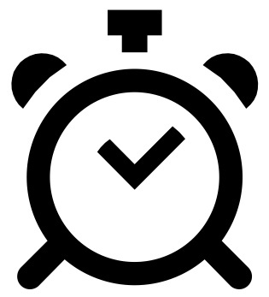” button, the display conversion to alarm activation mode, In this mode, press the “” button again to activate the alarm function, which is displayed as "ON", while the alarm icon "" is displayed。Also, in this mode the alarm has been activated, and then press “” button, you can turn off the alarm function, the display show "OFF" and the alarm icon "" does not show
 Press and hold down “” button for 2 seconds until Alarm Time hour display of the Alarm time starts to flash. Use the “▲” and “▼” buttons to set the required hour.
 Press “” button to confirm your setting, The Minute display of the Alarm time starts to flash. Use the “▲” and “▼” buttons to set the required minute.
 Press “” button to confirm your setting, the snooze time of the Alarm starts to flash. Use the “▲” and “▼” buttons to set the minute of snooze you need.
 Press “” button to confirm your setting and to end the setting procedure.
F.Y.I.:
 After 20 seconds without pressing any button the clock switches automatically from setting mode to Normal clock mode.
 The alarm will sound for 2 minutes if you do not deactivate it by pressing any button. In this case the alarm will be repeated automatically after 24 hours.
 Rising alarm sound (crescendo, duration: 2 minutes) changes the volume 4 times whilst the alarm signal is heard.
 the snooze time setting range: 5 ~ 60MIN, OFF, when set to OFF, means no snooze function. Snooze time unit is minutes.

Switching off the alarm signal
 The alarm sound when the trigger, press any button except the “” button or press hold the “” button for 2 seconds to stop the alarm signal.

Snooze function:
 Touch the “” field or press the “” button the alarm signal sounds to get to SNOOZE mode. The alarm signal sounds again after already been set.
 In snooze mode, press any button except the “” button or press hold the “” button for 2 seconds to exit the snooze mode.

Lunar phases and tide indicator:
 The weather station has a display which automatically displays the current lunar phase

 | 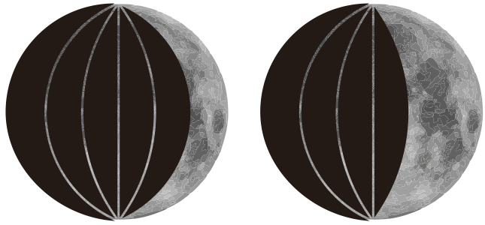 | 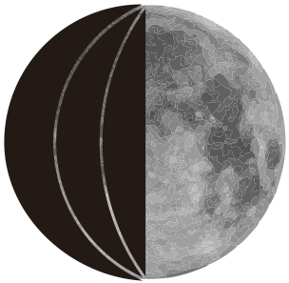 | 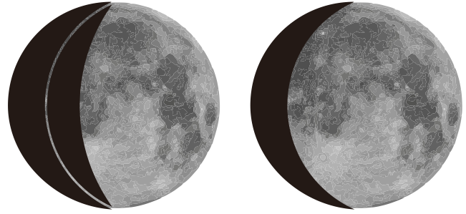 | 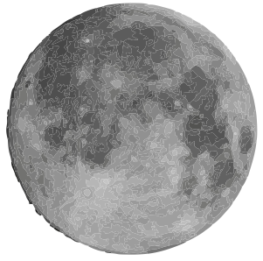 | 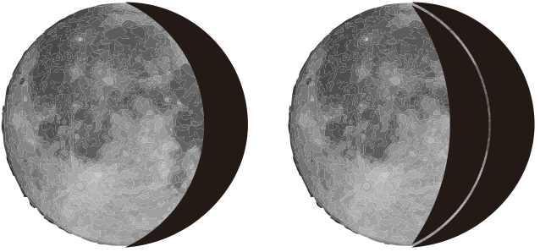 | 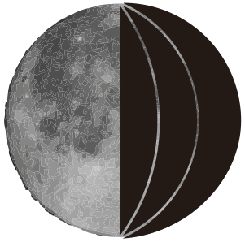 | 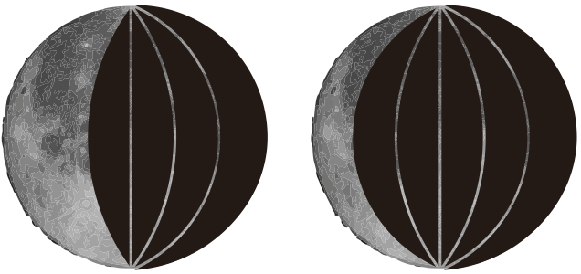
Nov | Dorůstající srpek | První  čtvrť | Dorůstající měsíc | Úplněk | Couvající měsíc | Poslední  čtvrť | Couvající srpek

Comfort display
 Indoor comfort level is calculated according to the indoor temperature and humidity, a total of 5 levels.


Comfortable too cold or too hot

Displaying temperature/humidity/ barometric pressure and temperature/humidity trend
 The current indoor temperature/humidity/barometric pressure and the temperature/humidity trend (indoors) are shown in the LCD display.
 After successfully connecting with the outdoor sensor, the weather station can display the outdoor temperature/humidity and the temperature/humidity trend (outdoor)
 You may see the following displays:
 The temperature/humidity is rising.
 The temperature/humidity is remaining constant.
 The temperature/humidity is falling.

RF Transmission Procedure:
 The weather station automatically starts receiving transmission from outdoor thermo sensor for outdoor temperature & humidity after batteries inserted.
 The outdoor sensor will automatically transmit temperature and humidity signal to the Weather Station after batteries inserted.
 If Weather Station failed to receive transmission from outdoor sensor (“- -”display on the LCD), press and hold “▼” button for 3 seconds to receive transmission manually. RF icon “” flashes on the LCD，The Weather Station to receive the outdoor sensor.

Maximum/Minimum Temperature/Relative Humidity
 To toggle indoor/outdoor maximum, minimum temperature and humidity data, press the “MEMERY” button:
Once to show the maximum temperature and humidity values.
Twice to sow the minimum temperature and humidity values
Three times to return to the current temperature and humidity levels
 To reset the maximum and minimum temperature and humidity, press and hold down the “MEMERY” button about 2 seconds. This will reset all minimum and maximum data recorded to the current displayed values.

F.Y.I.:
 If the temperature reading is below ranges, the LL.L will be displayed. If the temperature reading is above ranges, the HH.H will be displayed.

Outdoor Temperature alert setting
 Press and hold down the “” button for 2 seconds until the icon for the Temperature Alert” starts to flash
 The icon of Upper limit of the Temperature alarm starts to flash. Use the “▲” and “▼” buttons to set the required maximum temperature. Press “” to confirm your setting.
 The icon of the Lower limit of the Temperature alarm starts to flash. Use the “▲” and “▼” buttons to set the required minimum temperature. Press “” button to confirm your setting and to end the setting procedure

Temperature and frost alert
 Press “” button to activate or deactivate the remote temperature alert, When the remote temperature alarm is activated, the temperature alarm icon is displayed in the remote sensor bar
 When the remote channel temperature value exceeds the set temperature range, will activate the alarm, the weather station will every minute continuous alarm 5 times, at the same time, temperature alarm in alarm icon “” flashes, its temperature value and alarm upper limit icon “Hi” or lower limit icon “Lo” also flashes
 When the temperature of outdoor sensor is –1°C (+30°F) to + 3°C (+ 37°F), the frost alarm will be activated, the frost alert icon “” flashing.

F.Y.I.:
 When the temperature is higher than the upper limit of the alarm temperature setting, the activation of the upper limit alarm, symbol “Hi” flashing,
 When the temperature is lower than the lower limit of the alarm temperature, the lower limit alarm is activated, and the symbol “Lo” flashes

Low battery:
If the battery icon “” appears the batteries in the outdoor sensor should be replaced as soon as possible.

The weather forecast:
 The weather station calculates a weather forecast for about the next 12 hours based on the barometric pressure trend. Of course this forecast can‘t compare to that of professional weather services supported by satellites and high performance computers, but merely provides an approximate indication of current developments. Please take the weather forecast from your local weather forecasting service into account as well as the forecast from your weather station. If there are discrepancies between the information from your device and from the local weather forecasting service, please take the advice of the latter as authoritative.
 The weather station displays the following weather icon:

 |  |  |  | 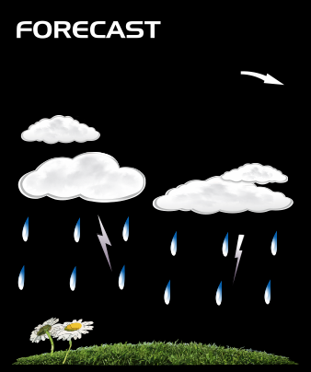 | 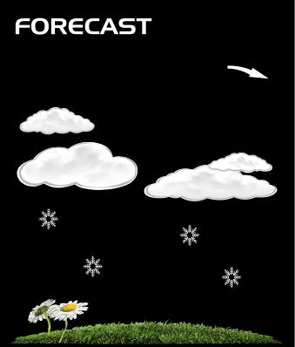
sunny | slightly cloudy | cloudy | rainy | Heavy rainy | Snowy

 The weather station can display the barometric pressure trend.
 You may see the following displays:
 The barometric pressure will rise.
 The barometric pressure will remain constant.
 The barometric pressure will fall.

Background lighting
 If the product is powered by batteries, touch the “” field or press the “” button. Backlight lit 15 seconds.
 When the power supply of the product is inserted into the power supply adapter, the battery will automatically disconnect the power supply, and the backlight will always be bright. Press the  button to adjust the brightness of the backlight, you can adjust the 4 state: 3 different brightness backlight and close the backlight. When the backlight brightness is not at the maximum brightness, touch the “” field or press the “” button. Backlight turns to maximum brightness of 15 seconds.

