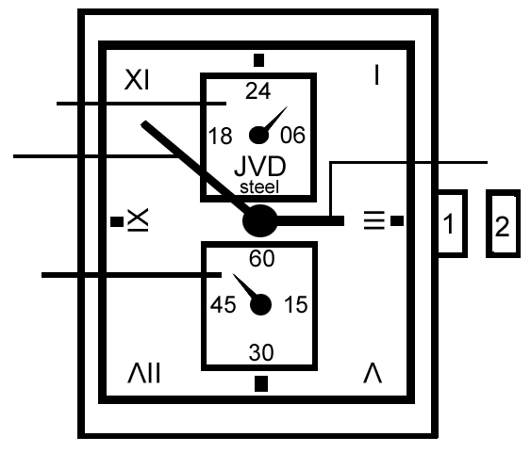
Instruction manual No.27

24-hour hand
minute hand hour hand
crown
second hand

- Crown in initial position
- Crown in position for time setting (pulled out)

Time setting
1. Pull crown out. Second hand stops moving (this can be used for precise time setting).
2. Turn crown to advance minute and hand hour. 24-hour hand moves automatically with the hour hand.
3. Return crown to initial position. Second hand starts moving.



