Basic Instructions No.1 JVD
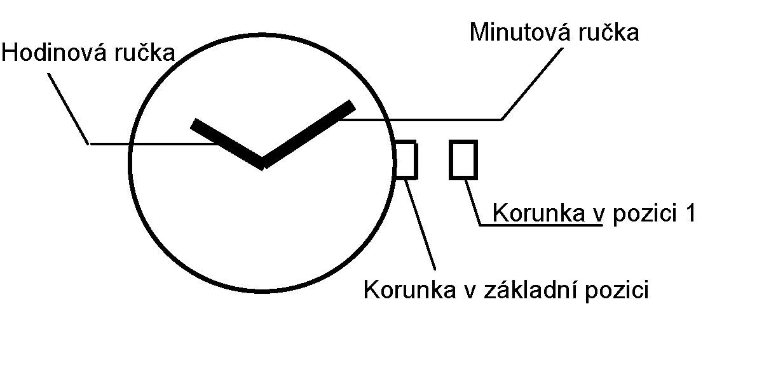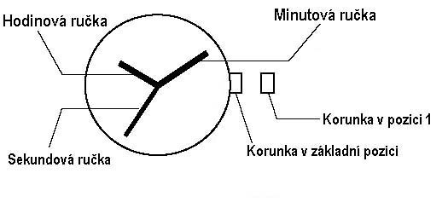
Second hand
Hour hand
Minute hand
Crown in initial position
Crown in position 1
Crown in initial position
Crown in position 1
Minute hand
Hour hand
Time Setting
1. Pull crown out to position 1. The hands stop moving.
2. Turn crown to advance minute and hour hand.
3. Return crown to initial position. The second hand starts moving.
