Instruction manual No.8

Instruction manual

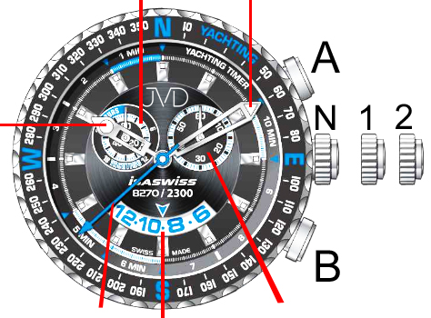
second hand of the stop watch minute hand

hour hand
Crown:
N: initial position
1: date setting
2: time setting

second hand date small second hand

Time setting:
- Pull crown out to position 2 when second hand is at 12:00.
- Turn crown to set time.
- Push crown back to initial position. Second hand starts moving again. The stopped second hand can be used for exact time setting.
Date setting:
- Pull crown out to position 1.
- Turn crown counterclockwise to set date.

ATTENTION:
- Never set date and day of week between 09:00 PM and 04:00 AM – the functions may not function properly!
- If the previous month had less than 31 days, it will be necessary to set the date manually at the beginning of the month.

Countdown setting:
1. Resetting the hands of countdown
- Press button A (second hand of the stopwatch will go around the dial – if it keeps on moving, press button A again – it will stop mobbing). Press button B – both of the hands of the stopwatch will go around the dial and stop in the initial position (12:00).
2. Countdown setting
- Press button A to start countdown if the hands are in initial position. You can adjust the amount of the countdown time by pressing button B (with every pressing, the hand moves and the countdown time shortens by 1 minute). By each pressing, the minute hand moves 1 minute ahead, the second hand runs around the dial and the countdown continues.
- You can break the countdown and restart it by pressing button A.
- If you want to pause the countdown, press button A – the countdown will stop. Press button B and the hands will go back to initial position.




