# Instruction manual No.10

## Instruction manual

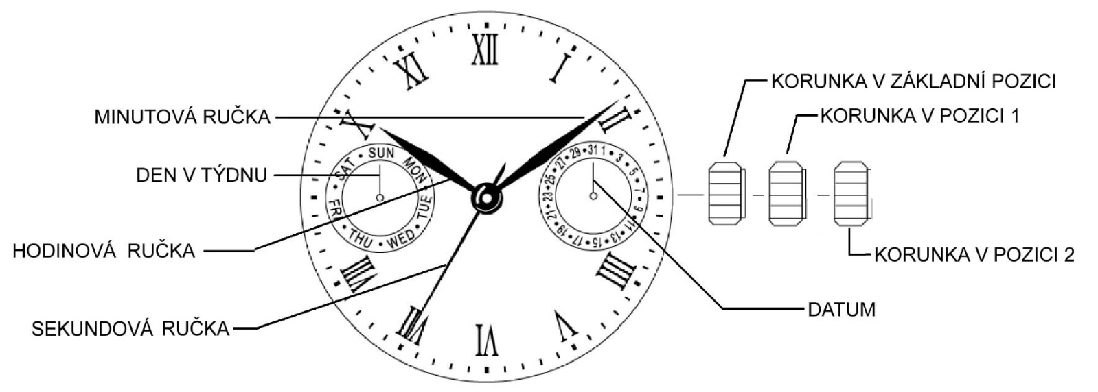

CROWN IN POSITION 2

DATE

CROWN IN POSITION 1

CROWN IN INITIAL POSITION

HOUR HAND

SECOND HAND

DAY OF WEEK

MINUTE HAND

**Position of crown:**

1. Day of week setting, time setting (hour, minute, second)

2. Date setting

##### Day of week and time setting:

The setting of hour, minute, second and day of week works in the same way.

**Sequence of settings**: it is necessary to keep the sequence of steps.



SECOND

MINUTE

HOUR

DAY

**Day of week setting:**

Pull crown out to position 2, so that the second hand stops in position 0 (12:00). Turn crown clockwise to move the hands until you set the day of week. To change the day, it is necessary to turn hands 24 hours.

**ATTENTION**: If you turn counterclockwise, the day of week function may not function properly. Do not set the function by turning counterclockwise! The change to the next day happens between 00:00 and 5:30 AM (sometimes a little bit later).

**Time setting:**

Set the hour and minute after you have set day of week.

Set the time by turning crown clockwise in position 2. First set the minute hand 5 minutes ahead. Then set the correct time by turning crown counterclockwise. Return crown to initial position. The Second hand starts moving.

**ATTENTION**: Make sure AM/PM is set correctly. The day starts at 00:01 AM. 13:01 = 01:01 PM.

**Date setting:**

Pull crown out to position 1. Turn crown counterclockwise to set the date.

**ATTENTION**: Never set the date between 09:00 OM and 00:30 am. The date function may not function properly.