Instruction manual No.26
Wristwatch – instruction manual
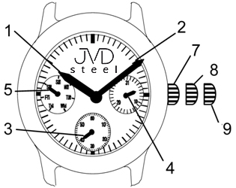

hour hand
- minute hand
- small second hand
- date
- day of week
- crown in initial position
- crown in position 1 – date setting
- crown in position 2 – time setting

Time, day of week and date setting
- Pull crown out to position 2 (9), when second hand (3) is at 12:00. The second hand stops moving.
- Turn crown to set day of week (the small hand has to pass 12:00 two times for day of week to change). Never set day of week between 22:00 and 02:00 (day of week would change at noon).
After setting day of week, turn crown to set time (make sure AM/PM is set correctly).
- Return crown to initial position (7). The second hand starts moving.
- Pull crown out to position 1 (8). Turn crown counterclockwise to set date.
- Return crown to initial position.




