Instruction manual No.29

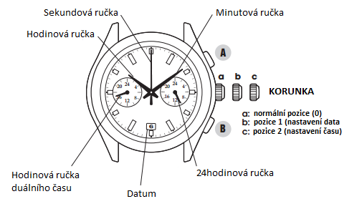**Elements of the dial**

Dual time hour hand

a: initial position (0)

b: position 1 (date setting)

c: position 2 (time setting)

24-hour hand

CROWN

Date

Minute hand

Hour hand

Second hand

1. **Time setting**

Pull crown out to position 2 when second hand reaches 12:00. Turn crown to move hour and minute hands to desired time. Push crown back to initial position. Second hand starts moving.

* *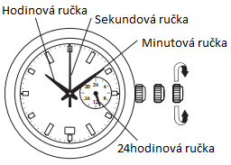24-hour hand in the right small dial will move along with the hour hand.*

Second hand

Minute hand hand

Hour hand

* *Date changes at midnight. Make sure that the AM / PM time is set correctly (pay attention to the position of the 24-hour hand).*

1. **Date setting**

Pull crown out to position 1. Turn crown to set date. Push crown back to initial position.

24-hour hand hand

* 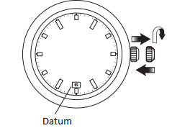*You will have to set date at the beginning of every month following a month shorter than 31 days.*
* *Do not set date between 09:00 pm and 01:00 am. The date would change during the day instead of at night.*

1. **DUAL TIME function**

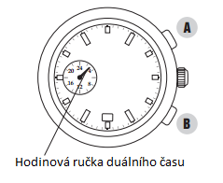If you are in a place where the time zone is different from that where the watch is usually used, you can use the hour hand of the left small dial to distinguish between time zones.

Date

* **Dual time setting**
  + Pull crown out to position 2 when second hand reaches 12:00.

Dual time hour hand

* + 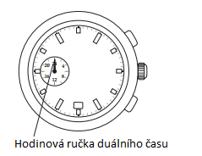Press button A or B to change the position of the hour hand. Each pressing moves the hour hand by 10 minutes.
  + Push crown back to initial position.

1. **Battery replacement**

Make sure that the hour hand of the left small dial is at 00:00 before you start setting time after battery replacement.

Dual time hour hand



