Instruction manual No.4 JVD

Instruction manual
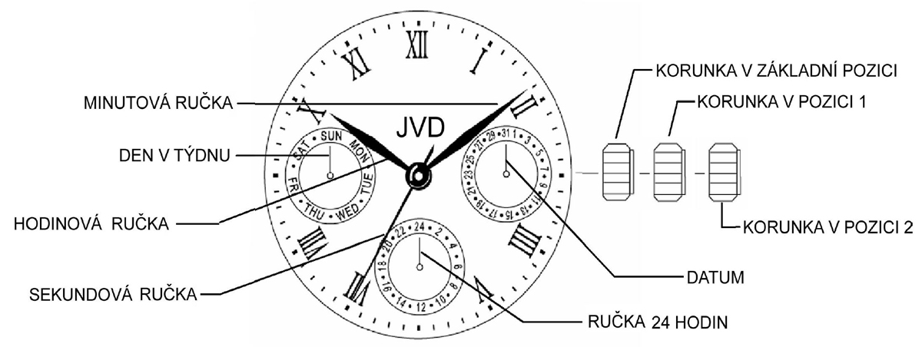
MINUTE HAND
HOUR HAND
DAY OF WEEK
SECOND HAND
24-HOUR HAND
DATE
CROWN IN INITIAL POSITION
CROWN IN POSITION 1
CROWN IN POSITION 2
Position of crown:
1. Day of week setting, time setting (hour, minute, second)
2. Date setting

Day of week and time setting:
The setting of hour, minute, second and day of week works in the same way.
Sequence of settings: it is necessary to keep the sequence of steps.
DAY
HOUR
MINUTE
SECOND

Day of week setting:
Pull crown out to position 2, so that the second hand stops in position 0 (12:00). Turn crown clockwise to move the hands until you set the day of week. To change the day, it is necessary to turn hands 24 hours.
ATTENTION: If you turn counterclockwise, the day of week function may not function properly. Do not set the function by turning counterclockwise! The change to the next day happens between 00:00 and 5:30 AM (sometimes a little bit later).

Time setting:
Set the hour and minute after you have set day of week.
Set the time by turning crown clockwise in position 2. First set the minute hand 5 minutes ahead. Then set the correct time by turning crown counterclockwise. Return crown to initial position. The Second hand starts moving.
ATTENTION: Make sure AM/PM is set correctly. The day starts at 00:01 AM. 13:01 = 01:01 PM.

Date setting:
Pull crown out to position 1. Turn crown counterclockwise to set the date.


ATTENTION: Never set the date between 09:00 OM and 00:30 am. The date function may not function properly.

