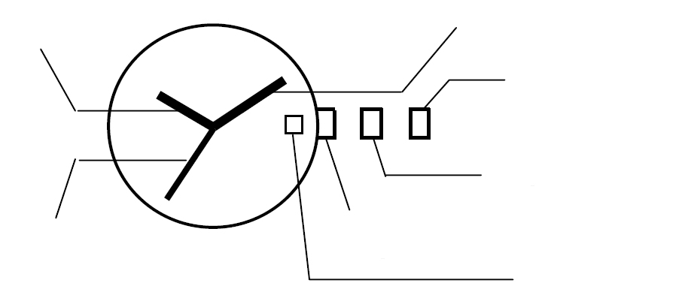
Instruction Manual No.2
Hour hand Minute hand
Crown in position 2

Crown in position 1
Crown in initial position
Second hand
*date
- Time setting
1. Pull crown out to position 2. The second hand stops moving.
2. Turn crown to advance minute and hand hour.
3. Return crown to initial position. The second hand starts moving.

- Date setting
- Pull crown out to position 1.
- Turn crown counterclockwise to set the date. (If you set the date between 21:00 and 1:00, the date will not change on the next day.)
- Return crown to initial position.

