**Instruction manual No.13**

Instruction manual

Elements of the dial:

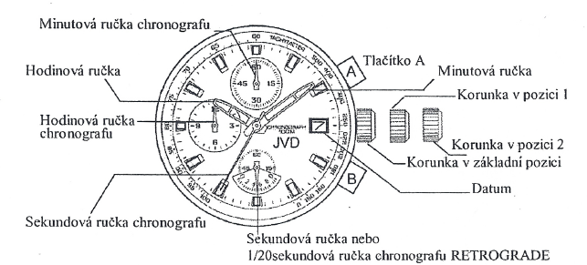

Second hand or

1/20 Second hand of the chronograph RETROGRADE

Minute hand

Crown in position 1

Crown in position 2

Date

Crown in initial position

Button B

Button A

Second hand of the chronograph

Hour hand of the chronograph

Hour hand

Minute hand of the chronograph

**Time setting:**

1. Pull crown out to position 2. (Second hand stops at 12:00.)
2. Turn crown to advance hour and minute hands.
3. Push crown back to initial position. Second hand starts moving.

**Date setting:**

1. Pull crown out to position 1.
2. Turn crown counterclockwise until you have set the correct date.   
   Do not set the date between 09:00 PM and 06:00 AM – the date would change at noon instead of at night. You will need to set the date again at the beginning of each month.
3. Push crown back to initial position.

**Using chronograph (stopwatch):**

The function of the chronograph is measuring time – it measures and shows time in 1/20 (1/1) seconds. The chronograph measures up to 12 hours.

The 1/20 (1/1) retrograde second hand of the chronograph will run 60 seconds and then stop at position 0.

**Measuring time using chronograph:**

1. Press button B to switch from the watch mode to the chronograph mode. Second hand of the watch will change its function to 1/20 retrograde second hand of the chronograph.
2. The chronograph can always be paused and restarted by pressing button A. The 1/20 retrograde hand of the chronograph will run 60 seconds and then stop at position 0. After stopping/pausing time measuring, the retrograde hand will move to show the measured time.
3. Press button B to reset the chronograph. All hands of the chronograph will return to position 0.

Movement of the retrograde hand is purely illustrative. The correct measured time will be shown after the time measuring has been stopped.

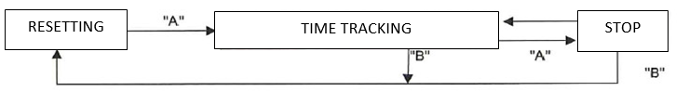

**Resetting stopwatch** (e.g. after battery replacement):

Follow these instructions if the second hand of the chronograph does not return to 00:00 after the reset of the stopwatch or after battery replacement.

1. Pull crown out to position 2.
2. Press button A to set second hand of the chronograph to position 00:00. You can speed up the process by holding button A.
3. Press button B to set 1/20 retrograde second hand of the chronograph to position 00:00. You can speed up the process by holding button B.
4. When the hands of the chronograph are at 00:00, set time and push crown back to initial position.
5. Press button B to check that the hands of the chronograph are really at 00:00

*Do not push crown back to initial position unless the hands are at 00:00. If you pushed the crown before the hands reach 00:00, the point at which they stopped would be set as the new initial point (00:00).