**JVD – RB9299 – user manual (EN)**

**1. Feature**

**1.1 Time**  - Radio controlled time with manual setting option

- 12/24 hour time display selectable

- Dual Alarm function

- Perpetual Calendar Up to Year 2099

- Day of week in 10 languages user selectable

**1.2 Temperature** - Indoor measurable range: -10°C ~+ 50°C

- Measures °C / °F user selectable

**2. Main Unit Appearance**

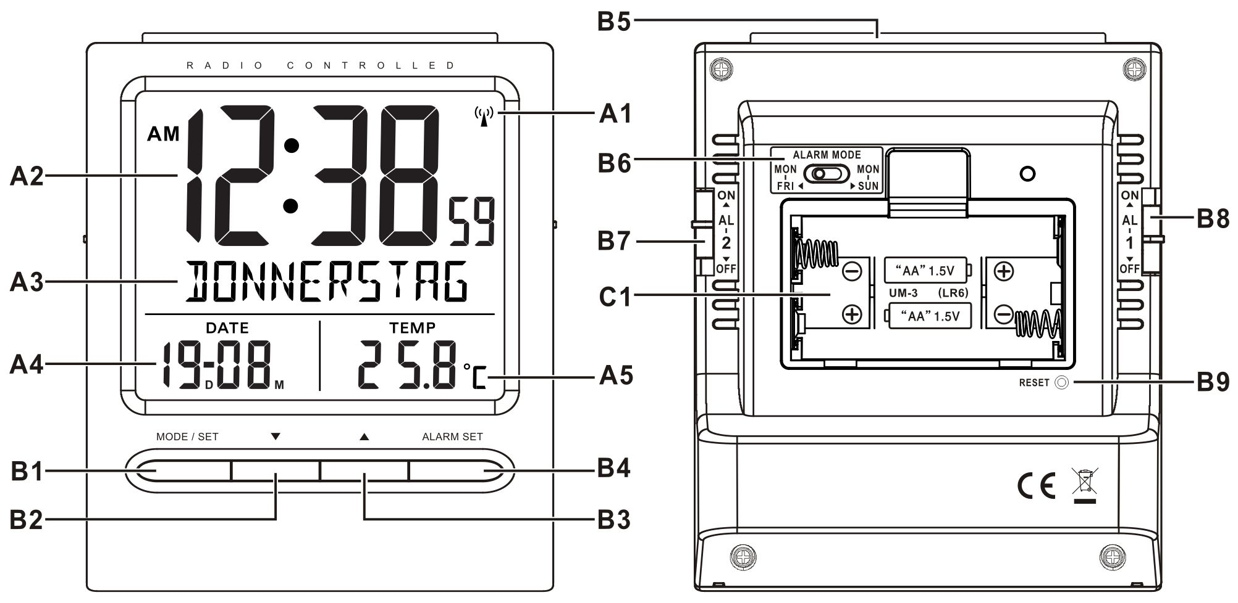

P art A-LCD

A1: Radio control icon

A2: Time

A3: Day of Week

A4: Date/Alarm time 1

A5: Temperature/Alarm time 2

**Part B-Button**

B1: “MODE/SET” button

B2: “▼” button

B3: “▲” button

B4: “ALARM SET” button

B5: “SNOOZE/LIGHT” button

B6: ALARM MODE slide switch

B7: “AL 2 “ON/OFF” slide switch

B8: AL1 “ON/OFF” slide switch

B9: “RESET” button

**Part C-Structure**

C1: Battery Door

**3. Getting Started:**

* Open battery Cover (C1)
* Insert 2 pieces AA size batteries observing polarity [“ +” and “ –“ marks]
* Replace battery compartment cover
* The unit can be placed onto any flat surface; the unit is ready for use now.

**4. Time and Alarm Setting**

**4.1 Radio Controlled Clock:**

* After the start-up of the unit, the clock automatically starts to scan the DCF time signal. Radio Control Icon “” flashes on LCD.



|  |  |  |
| --- | --- | --- |
| flashes,  Indicating now is receiving DCF signal | turns on,  Indicating signal received successfully | disappear,  Indicating signal reception failed |

* The clock automatically synchronized with the DCF radio signal every day at 2.00 am & 3.00 a.m. to maintain accurate time keeping. If synchronization with the DCF radio signal fails, “” on LCD disappear.



* The clock can be set to scan the radio signal manually by holding “▼” button for 2 seconds. Each reception takes around several minutes. If receptions fail, scanning stops (“” on LCD disappear).



* Stop scanning DCF radio signal manually by holding “▼” button for 2 seconds.
* “**DST**” shown on the LCD if it is in Daylight Saving Time Mode

**4.2 Manual Time Setting:**

* In time display mode, press “MODE/SET” button to view the year. Hold “MODE/SET” button for 3 seconds to enter Clock/Calendar setting Mode.
* Press “▲” or “▼” button to adjust the setting and press “MODE/SET” button to confirm each setting.

*(By keeping the “*▲*” or “*▼*” button pressed, could accelerate the process and reach the desired value more quickly)*

* The setting sequence is shown as follow: 12/24 Hour, Temperature Unit, Time Zone, Weekday language, Hour, Minute, Second, Year, Month/Date Sequence, Month, Date.
* There are 10 languages for day of week: German, English, French, Italian, Dutch, Spanish, Danish, Czech, Polish, Swedish

***Note****:*

1. *All setting modes will automatically exit in 15 seconds without any adjustment*
2. *For Time Zone: The Time zone is used for the countries where can receive the DCF time signal but the time zone is different from the German time. When the country time is faster than the Germany time for 1 hour, the zone should be set to 01. Then the clock will automatically set 1 hour faster from the signal time received.*

*If you cannot receive RC-DCF frequency signal, the time zone should be set to 00.*

**4.3 Dual Daily Alarm Setting:**

* Press “ ALARM SET” button, time of alarm 1 flashes, press “▲” or “▼”button to adjust the alarm time. Press “ALARM SET” button to confirm the setting and move to the setting of alarm 2, press “▲” or “▼”button to adjust the time for alarm 2, press “ALARM SET” button to confirm and exit the setting

*(By keeping the “*▲*” or “*▼*” button pressed, could accelerate the process and reach the desired value more quickly)*

**4.4 Snooze Alarm Function:**

* Slide “AL 1” or “AL 2” switch to “ON” to activate the ALARM 1 or ALARM 2 function. Alarm time and alarm icon“” appear on the display.



* When alarm alerts, press any button to stop the alarm. Otherwise, the alarm signal sounds for about 3 minutes, then stops automatically
* Press “SNOOZE/LIGHT” button when alarm alerts. “” flashes on the LCD. The alarm snoozes for around 5 minutes, then it alerts again. The snooze function can be enabled for maximum 7 times.



* Except “SNOOZE” button, press any button to stop the snooze alarm, or slide “AL 1” or “AL 2” ON/OFF slide switch to deactivate alarm function. Alarm icon “” disappear from the display.



Slide alarm mode switch (B6) to select the daily alarm alerts in weekday only from Monday to Friday or daily.

**5. Thermometer**

* If the temperature is out of the measurable range, LL.L (beyond the minimum temperature) or HH.H (beyond the maximum temperature) will be shown on the LCD.

**6. Backlight**

Press “SNOOZE/LIGHT” button, back light states for 5 seconds.

**7. Low battery**

Please replace new battery when low battery icon “” appears.



**8. Precautions**

* *The clock loses its time information when the battery is removed.*
* *Do not expose it to direct sunlight, heavy heat, cold, high humidity or wet areas*
* *Never clean the device using abrasive or corrosive materials or products. Abrasive cleaning agents may scratch plastic parts and corrode electronic circuits*



**Supplier:**

**Jasněna Vláhová, s.r.o.**

**Přibyslav 77, 549 01 Nové Město nad Metují, CZ**

**www.vlahova.cz**