INSTRUCTION MANUAL No.31

DISPLAYS AND BUTTONS
- SETTING THE TIME
- SETTING THE DATE
- USING THE STOPWATCH
- STOPWATCH RESET
- DISPLAYS AND BUTTONS

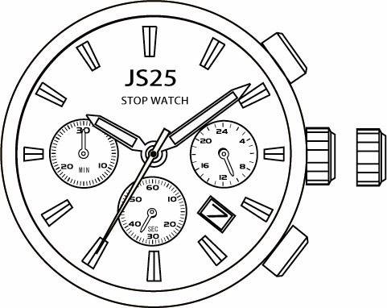
Button A
Normal Position
1st Click Position

Stopwatch Minute Hand

Second Hand

2nd Click Position

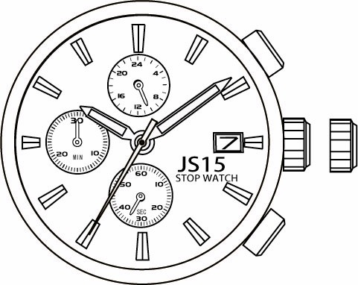
24 Hour Hand

Stopwatch Second Hand

Calendar
24 Hour Hand Button B

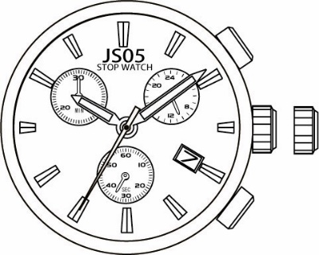
24 Hour Hand

Stopwatch Minute Hand
Stopwatch Minute Hand

Second Hand

Stopwatch Second Hand

Second Hand

Stopwatch Second Hand

- SETTING THE TIME
- Pull the crown out to the 2nd Click Position.
- Turn the crown to set hour and minute hands.
- After the time has been set, push the crown back to the Normal position.

SETTING THE DATE
- Pull the crown out to the 1st Click Position.
- Turn the crown clockwise to set the date.
* If the date is set between the hours of around 9:00 PM and 1:00 AM, the date may not change on the following day.
- After the date has been set, push the crown back to the Normal position.

USING THE STOPWATCH
This stopwatch is able to measure and display time in 1/1 second united up to maximum of 30 minutes. Stopwatch will stop automatically after running continuously for 30 minutes.

[Measuring time with the stopwatch]
- Press button "A" to start the stopwatch.
- The stop watch can be started and stopped each time button "A" is pressed.
- Pressing button "B" resets the stopwatch and stopwatch minute and second hands return to their Zero positions.
“A”
Reset
“A”
Time Measurement
 | Stop
“A” |  | “B”

STOPWATCH RESET (INCL. AFTER REPLACING BATTERY)
This procedure should be performed when the stopwatch second & minute hand does not return to the Zero position.
- Pull the crown out to the 2nd Click Position.
- Press the button "A" to set the stopwatch second hand forward. Press the button "B" to set the stopwatch second hand back.
  - The stopwatch minute hand is synchronized with stopwatch second hand.
  - The stopwatch second hand can be advanced rapidly by continuously pressing button "A" or "B".
- Once the both hands been zeroed, reset the time and return the crown to its normal position.

These specifications might be changed without prior notice

