Slim Touch Weather Station with 868MHz Remote Sensor
Model: RB503

INSTRUCTION MANUAL
Congratulations on your of purchasing this new Weather Station. This unique product is designed for everyday use for the home or office and is a definite asset of great use. To fully benefit from all the features and understand the correct operation of this product, please read this instruction manual thoroughly.

FUNCTIONS OF THE WEATHER STATION
This weather station measures the environment of its surrounding area and receives weather data transmitting from up to three outdoor thermo-hygrometers for temperature.
The data is continuously updated to bring you the latest weather information displayed on the LCD of the receiving unit. Its wireless 868MHz can transmit data over a distance of 65 meters (210 feet) in open space.
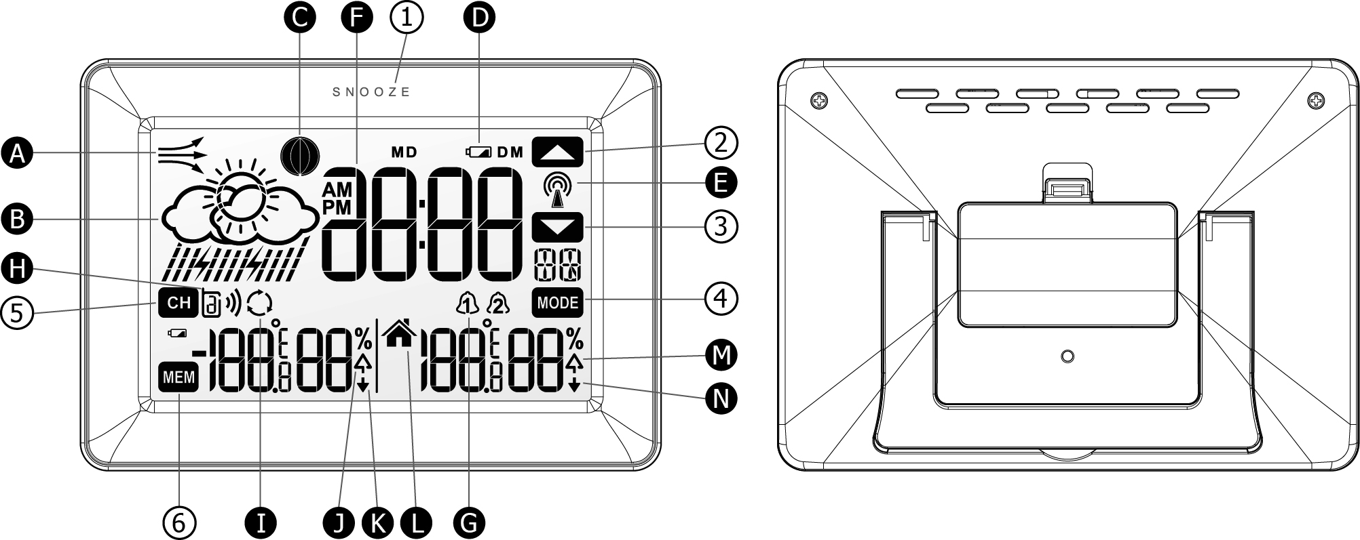
Front view Back view

FEATURES: MAIN UNIT
- Air pressure trend arrows
It is to Indicate the trend of air pressure changes.
- Weather forecast window
Display weather forecast icons for sunny, slightly cloudy, cloudy, rainy and stormy.
- Moon phase
Show current moon phase.
- Low battery indicator
It is to indicate the backup battery in the unit is low and the user needs to change the batteries at once
E. Radio controlled clock time indicator
It is to indicate the displayed clock time is received from RCC station.
F. Clock time
Display current time or alarm time.
- Alarm on icon
It is shown when the daily alarm clock is enabled.
- Remote sensor indicator
It is to indicate which channel of remote sensor is being used. It can display up to 3 different remote sensors which are in different locations and within 65 meters (210 feet) distance away from the main unit.
I. Auto scroll indicator
The arrow icon is shown to indicate the auto scroll of 3 different remote channels.
- Outdoor maximum icon
It is to indicate the maximum outdoor temperature/humidity that is being displayed.
- Outdoor minimum icon
It is to indicate the minimum outdoor temperature/humidity that is being displayed.
- Indoor temperature icon
It is to indicate the indoor temperature/humidity is being displayed.
- indoor maximum icon
It is to indicate the maximum indoor temperature/humidity that is being displayed.
- indoor minimum icon
It is to indicated the minimum outdoor temperature/humidity that is being displayed.

DESCRIPTION OF BUTTONS
WSA503 has 6 major function touch buttons.
- [SNOOZE/LIGHT]
Press once to activate the LCD backlight for 5 seconds or snooze function.
Press once to work up the touch keys if they are not appeared on the screen.
- [ ]
Press once to increase the value in CLOCK, CALENDAR or ALARM setting mode.
In alarm mode, press this key to enable/disable the alarm 1 or 2.
- [ ]
Press once to decrease the value in CLOCK, CALENDAR or ALARM setting mode.
In alarm mode, press this key to enable/disable the alarm 1 or 2.
- [ MODE ]
Toggle amongst display for Clock-Sec (HR-MIN-Sec), Clock-day (HR-MIN-Weekday), Calendar (Date-Month-Weekday),Alarm 1, Alarm 2 and repeat…
Press & hold 2 seconds to access setting mode of clock and alarm
- [ CH ]
Select among channel 1, 2, 3 or to enter auto scroll mode.
Press and hold for 2 seconds to activate or deactivate the sensor searching mode.
In RF register mode, press and hold for 2s to exit this register mode
- [ MEM ]
Press once to view the Max/Min reading of the indoor & outdoor temperature/humidity. After 5 seconds, will go back to current temperature/humidity.
When the max/min value is displayed, press and hold for 2 seconds to clear the memorized Max/Min readings of the indoor & outdoor temperature/humidity.
If RCC is not receiving, press and hold for 3 seconds to activate RCC. If RCC is receiving, press this key to deactivate RCC.
Note: If there is no key pressed for 20 seconds, touch keys will disappear on the screen unless press once the “Snooze” button.

GETTING STARTED
This Weather Station was designed for easy set up. For best operation, the following steps are required to be done in the proper sequence.
- Insert batteries for main unit before doing so for the sensor units.
- Receiving unit cannot be programmed manually until the wirelss remote sensor unit registration procedure has been completed.
- Position the remote unit and main unit within effective transmission range, which, in usual circumstance, is 210 feet.
Although the remote unit is weather resistant, it should be placed away from direct sunlight, rain or snow.

BATTERY INSTALLATION FOR MAIN UNIT
- Remove the battery door.
- Insert 2 pieces of AAA size 1.5V alkaline battery as indicate by the polarity.
- Close the battery door.
Note: Replace the batteries when the low battery indicator appears on the top-right corner of the LCD.

BATTERY INSTALLATION FOR REMOTE SENSOR UNIT
- Remove the battery cover by grabbing its bottom edge (near the two recess location) from bottom of sensor unit.
- Insert 2 pieces of AA size batteries according to the “+” and “-” polarity marks shown in the battery compartment and then close the battery door with the clip on. (press down the snap on both sides slightly).
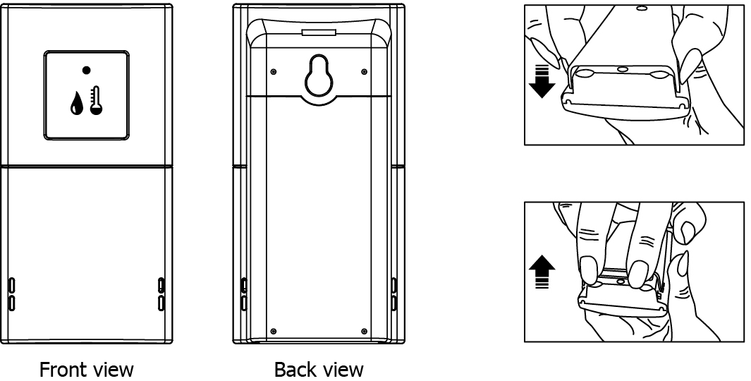
WIRELESS REMOTE SENSOR REGISTRATION PROCEDURE
- Insert 2 pieces of AAA batteries first to the main unit. The outdoor temperature display shows - - . – while the wave icon will keep blinking for 2 minutes indicate the main unit is in sensor searching mode.
- In a second step, insert the 2 pieces of AA batteries into the sensor unit. The LED on the front panel will start flashing at a rate of one time per around 2 seconds indicates channel-1 is being used.
- While the LED is flashing on remote sensor, press once the [CH] key will change the sensor channel setting to 2. Keep toggle on [CH] key can change channel setting up to 3. The LED is blinking at a frequency to indicate the channel setting. i.e. continuous blinks 2 times indicate channel 2 is selected.
Note: If user does not press any key for 10 seconds, it will exit the channel setting mode and transmit the RF signal. The main unit will register the temperature reading.

REMOTE CHANNEL AUTO-SCROLLING
This device is equipped with an auto-scroll function. While the auto-scroll function is set, the unit will automatically cycle to display the temperature and humidity of each remote sensor for 6 seconds.
- To retrieve manually the specific sensor temperature and humidity reading, press CH key until desired channel number is displayed
- To enable auto-scroll function, use CH button to toggle channel 1, 2 or 3 until auto scroll icon appears on the left hand side of the second line display.

DCF 77 RADIO CONTROLLED CLOCK
The radio-controlled time is calculated by the Cesium Atomic clock of Braunschweig (official clock of Germany).
Then the time is coded and transmitted from Mainflingen - near Frankfurt - via a signal on DCF-77 (77.5 kHz). The transmitting range of the signal is 500 km, which means that most of Western and Central Europe is covered by this signal. Within this range the received time is completely accurate. Once sensor signal(s) are received, the wave icon
will flash to indicate that the receiving unit starts to receive the DCF radio controlled time signal.
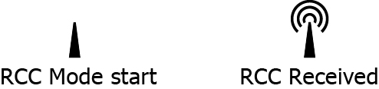
Once the time signal is received, the wave icon will stay on the LCD, and time and calendar will automatically be updated.
Note: During the 10-minute time signal reception, all manual settings will be suspended. If setting is desired, press once [ MEM ] key to deactivate the reception. You can also press and hold the same key for 3 seconds to manually activate the reception in normal mode.

SET THE CLOCK, CALENDAR & LANGUAGE & Temperature Unit & RCC ON/OFF
- Press & hold [MODE] button for 2 seconds to enter clock setting mode. Flashing 12/24 hours will appear.
- Press [ ] or [ ] button to switch between 24 hours and 12 hours format, and then press [MODE] button to confirm.
4. The time zone digits will flash.. Use the [ ] button to decrease by one hour or [ ] button to increase by one hour to your desired hour. Press [MODE] button to confirm.
Note: The range of time zone setting can be reach to( -12 ~ +12)
5. The hour digits will flash. Use the [ ] button to decrease by one hour or [ ] button to increase by one hour to your desired hour. Hold press either button will change the digit rapidly. Press [MODE] button to confirm.
6. The minute digits will flash. Use the [ ] or [ ] button to set your desired minute. Hold press either button will change the digit rapidly. Press [MODE] button to confirm.
Note: Every change of minute digit will automatically reset the seconds to zero.
7. The year digit will flash and Yr icon appears. Press [ ] or [ ] button to set your
desired year. Press [MODE] button to confirm.
Note: Year range is from 2000 to 2099.
8. D and M icons will flash. Press [ ] or [ ] to select D M (Date Month) or M D (Month Date) format. Press [MODE] button to confirm.
- Month digits will flash. Press [ ] or [ ] button to set your desired month. Press [MODE] button to confirm. Do the same to set Date.
Note: The moon phase and the weekday will be automatically calculated and displayed according to the date set as above.
- E digit will flash. Press [ ] or [ ] button to switch 5 languages display of weekday (English/German/French/Spanish/Italian. See table 1). Press [MODE] button to confirm and exit setting mode.
- Temperature units will flash, Press [ ] or [ ] button to switch between Celsius and Fahrenheit. Press [MODE] button to confirm your desired temperature unit.
- ON icon will flash, Press [ ] or [ ] button to switch between ON and OFF. Press [MODE] button to confirm your desired. If it is set to OFF, then the RCC function will be closed.
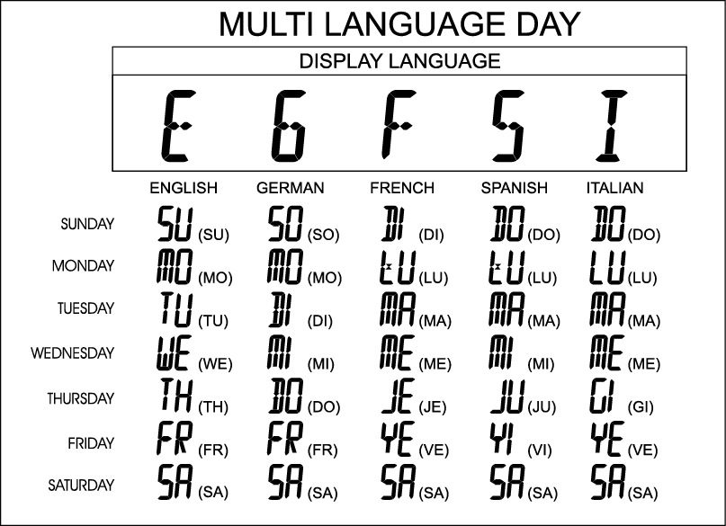
Note: If there is no key pressed during setting mode for 10 seconds, it will automatically keep the setting and exit to normal display.

TO SET DAILY ALARM
- In clock time display mode, press [MODE] button to select alarm 1 or 2, then hold and press [MODE] again for 2 seconds to access alarm setting.
2. The hour digits will flash, use [ ] button to decrease by one hour or [ ] button to increase by one hour to your desired hour. Hold press either button will change the digit rapidly. Press [MODE] button to confirm,
3. The minute digits will flash. Use [ ] button to decrease by one minute or [ ] to increase by one minute to your desired minute. Hold press either button will change the digit rapidly. Press [MODE] button to confirm. The unit will show the alarm time for 10 seconds and exit to clock time display automatically. The alarm bell icon will be turned on in clock time display to indicate that the daily alarm is enabled.
Note: If there is no key pressed in the setting mode for 10 seconds, it will automatically save the set value and exit to normal display.
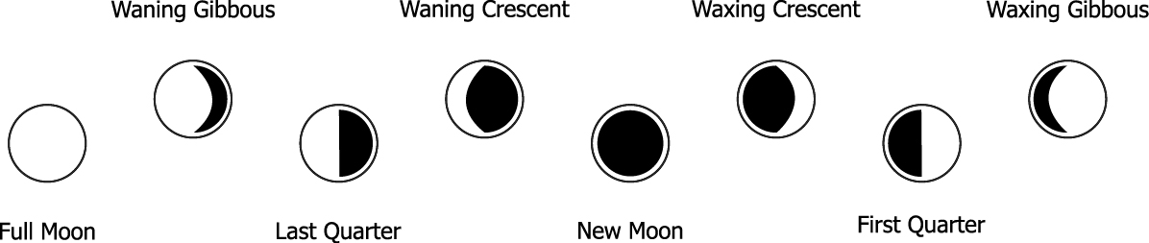
MOON PHASE
Our weather station is equipped with 8 moon phases display (i.e. from new moon to waning crescent) on the screen.

WEATHER FORECAST
Our weather station is capable of detecting local barometric pressure changes, and based on the data collected, predicts the weather forecast for the next 12 to 24 hours.

Note:
1. The accuracy of a general pressure-based weather forecast is about 70 to 75%, and therefore, we cannot be held responsible for any inconveniences so caused by an inaccurate one.
2. The weather forecast is meant for the next 12 to 24 hours. It may not necessarily reflect the current situation.
3. The ‘Sunny’ forecast covering night hours indicates clear weather.

SPECIFICATIONS
Main Unit
Displayed IN temperature range : -10°C to +60.0°C (14°F to 140.0°F)
Proposed operating range : 0°C to +50.0°C (32.0°F to 122.0°F)
Temperature resolution : 0.1°C (0.2°F)
Remote Temperature measurement
Displayed OUT temperature range
(for model: Remote unit connected with external wire only) : -40.0°C to +60.0°C (-40.0°F to 140.0°F)
Temperature resolution : 0.1°C (0.2°F)
Indoor/Remote relative humidity measurement
Displayed Relative Humidty range : 20%RH to 99%RH
Measured temperature range : -10°C to +50.0°C
Remote Unit
Proposed operating range : -10.0°C to +50.0°C (14.0°F to 122.0°F)
Temperature resolution : 0.1°C (0.2°F)
Displayed Relative Humidty range : 20%RH to 99%RH
Measured temperature range : -10°C to +50.0°C
RF Transmission Frequency : 868 MHz
Open Field RF Transmission Range : 65 meters
Temperature transmission cycle time : 120 seconds

You can help protect the environment!
Please remember to respect the local regulations: hand in the non-working electrical equipments to an appropriate waste disposal center.

The information in this document has been viewed and is believed to be accurate. However, neither the manufacturer nor its affiliates assume any responsibility for inaccuracies, errors or omissions that may be contained herein. In no event will the manufacturer or its affiliates be liable for direct, indirect, special, incidental or consequential damages arisen by using this product or resulting from any defect/omission in this document, even if advised of the possibility of such damages. The manufacturer and its affiliates reserve the right to make improvements or changes to this document and the products and services described at any time, without notice or obligation.

Battery shall not be exposed to excessive heat such as sunshine, fire or the like.
Market supplyer:
Jasněna Vláhová
Nové Město nad Metují
www.vlahova.cz



